The Violence of Earth

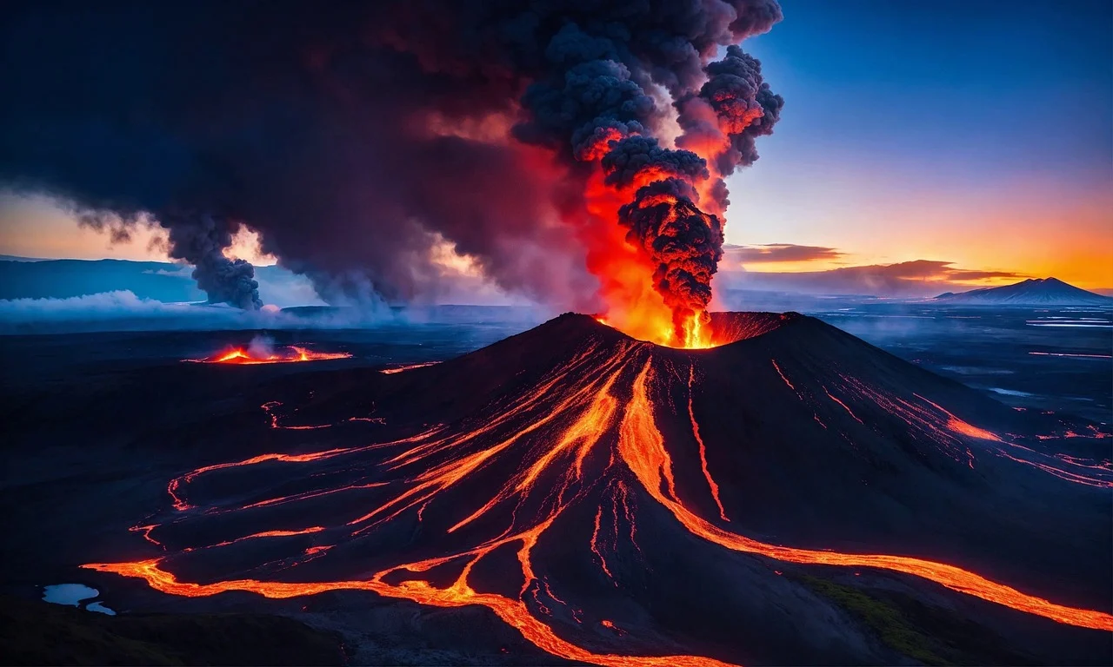

<https://pixabay.com/illustrations/ai-generated-volcano-lava-fire-8510610/>

